

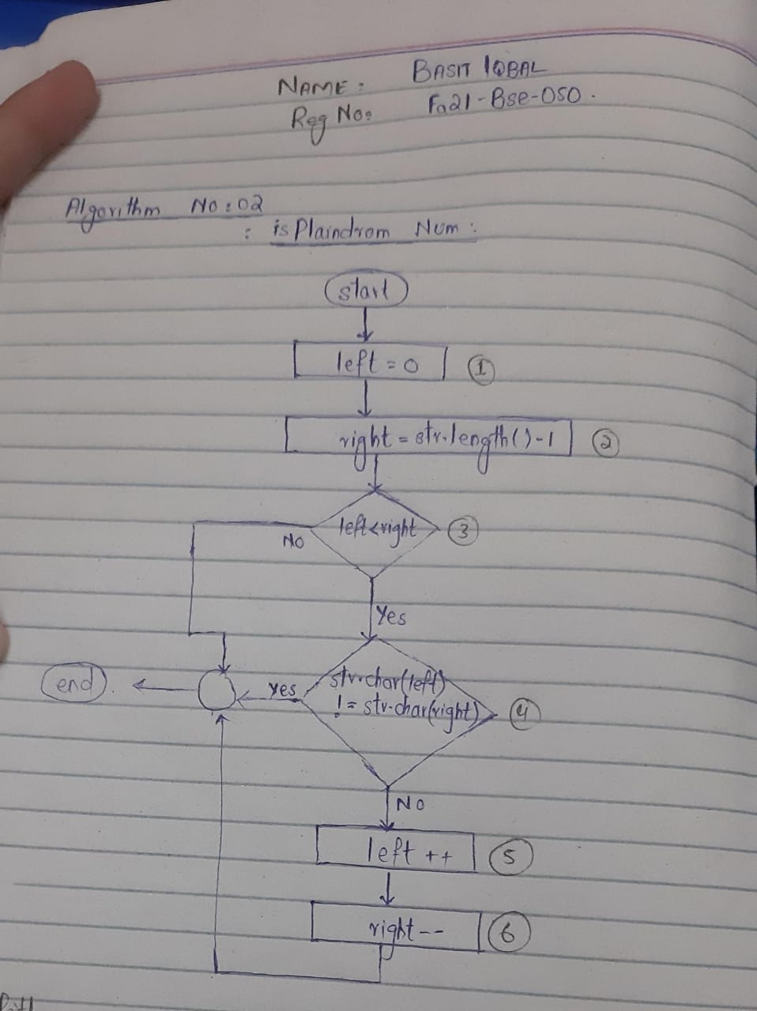

**TEST CASES:**

|  |  |  |  |  |  |
| --- | --- | --- | --- | --- | --- |
| Test Case Id | Test Case Description | Input Data | Expected Output | Actual Output | Verdict |
| TC_001 | To check that the string having only one character is palindrome | Str=’a’ | Message displayed: Is the string a palindrome? true | Message displayed: Is the string a palindrome? true | Pass |
| TC_002 | To check that the string entered having two different character is not a palindrome | Str=’ab’ | Message displayed: Is the string a palindrome? false | Message displayed: Is the string a palindrome? false | Pass |
| TC_003 | To check that the string entered is palindrome. | Str = ‘mam’ | Message displayed: Is the string a palindrome? true | Message displayed: Is the string a palindrome? true | Pass |

**OUTPUTS:**  
**TC_001:**

**Tc_002:**

**TC_003:**

**CODE:**  
SRC>MAIN>PalindromeCheck:

SRC>TEST>PalindromeCheckTest:

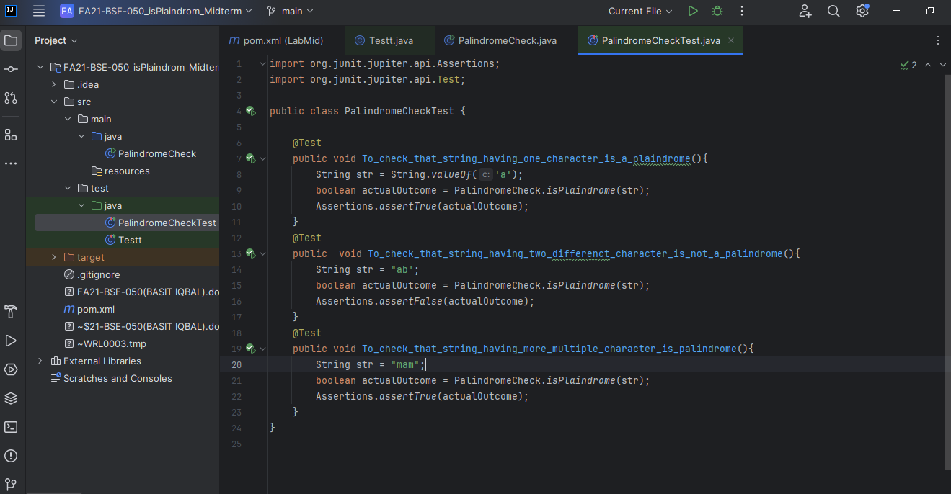

Output of the Automation Testing:  
